Physical-to-Cloud (P2C) Migration

🌟 Definition
# Source: AI Source: Provided by: [Data Path: Persons Table -> ID Column: 1, Name_En Column: Motasem Essam] -> From: [ChatGPT] on [6/7/2026]
Physical-to-Cloud (P2C) Migration is the process of moving a physical server and its workloads directly to a cloud environment.
The migration transfers:
- Operating System
- Applications
- Databases
- Files
- Services
- Configurations
from a physical server to cloud infrastructure.

🎯 Purpose
# Source: AI Source: Provided by: [Data Path: Persons Table -> ID Column: 1, Name_En Column: Motasem Essam] -> From: [ChatGPT] on [6/7/2026]
Organizations perform P2C migration to:
- Eliminate on-premises hardware
- Reduce infrastructure costs
- Improve scalability
- Improve disaster recovery
- Increase availability
- Support remote access
- Modernize IT infrastructure

🧠 Simple Definition
# Source: AI Source: Provided by: [Data Path: Persons Table -> ID Column: 1, Name_En Column: Motasem Essam] -> From: [ChatGPT] on [6/7/2026]
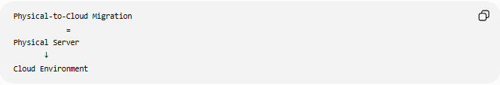
Physical-to-Cloud Migration
=
Physical Server
↓
Cloud Environment

📚 What is the Cloud?
# Source: AI Source: Provided by: [Data Path: Persons Table -> ID Column: 1, Name_En Column: Motasem Essam] -> From: [ChatGPT] on [6/7/2026]
The cloud provides computing resources over the internet.
Examples:
- Amazon Web Services
- Microsoft
- Google

Instead of owning hardware, organizations rent:
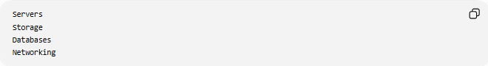
Servers
Storage
Databases
Networking
from cloud providers.

🔍 P2C Migration Overview
# Source: AI Source: Provided by: [Data Path: Persons Table -> ID Column: 1, Name_En Column: Motasem Essam] -> From: [ChatGPT] on [6/7/2026]
Before
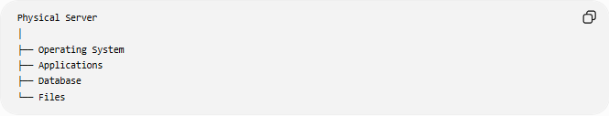
Physical Server
│
├── Operating System
├── Applications
├── Database
└── Files
Located in:
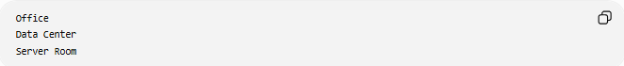
Office
Data Center
Server Room

After
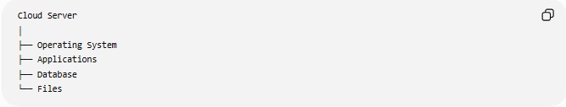
Cloud Server
│
├── Operating System
├── Applications
├── Database
└── Files
Hosted in the cloud.

🏗️ Common Scenarios

1️⃣ Data Center Exit
# Source: AI Source: Provided by: [Data Path: Persons Table -> ID Column: 1, Name_En Column: Motasem Essam] -> From: [ChatGPT] on [6/7/2026]
Before
Company Data Center

After
Cloud Platform

Benefits:
No Hardware Maintenance
Lower Infrastructure Costs

2️⃣ Legacy Server Modernization
# Source: AI Source: Provided by: [Data Path: Persons Table -> ID Column: 1, Name_En Column: Motasem Essam] -> From: [ChatGPT] on [6/7/2026]
Before
Old Physical Server

After
Cloud Virtual Machine

Benefits:
Better Reliability
Scalability

3️⃣ Business Expansion
# Source: AI Source: Provided by: [Data Path: Persons Table -> ID Column: 1, Name_En Column: Motasem Essam] -> From: [ChatGPT] on [6/7/2026]
Before
Local Infrastructure

After
Global Cloud Infrastructure

Benefits:
Worldwide Availability

🛠️ Real-World Example
# Source: AI Source: Provided by: [Data Path: Persons Table -> ID Column: 1, Name_En Column: Motasem Essam] -> From: [ChatGPT] on [6/7/2026]
Before Migration
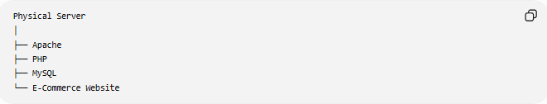
Physical Server
│
├── Apache
├── PHP
├── MySQL
└── E-Commerce Website
Problems:
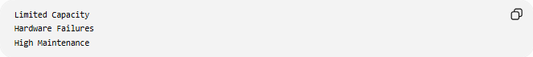
Limited Capacity
Hardware Failures
High Maintenance

Migration
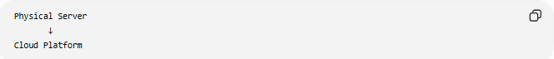
Physical Server
↓
Cloud Platform

After Migration
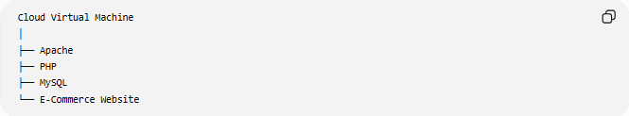
Cloud Virtual Machine
│
├── Apache
├── PHP
├── MySQL
└── E-Commerce Website

Benefits:
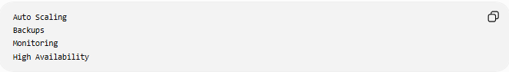
Auto Scaling
Backups
Monitoring
High Availability

🔄 Migration Lifecycle
# Source: AI Source: Provided by: [Data Path: Persons Table -> ID Column: 1, Name_En Column: Motasem Essam] -> From: [ChatGPT] on [6/7/2026]
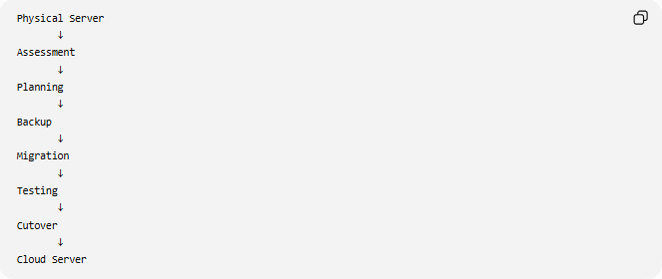
Physical Server
↓
Assessment
↓
Planning
↓
Backup
↓
Migration
↓
Testing
↓
Cutover
↓
Cloud Server

📦 What Gets Migrated?
# Source: AI Source: Provided by: [Data Path: Persons Table -> ID Column: 1, Name_En Column: Motasem Essam] -> From: [ChatGPT] on [6/7/2026]
Operating System
Examples:
- Microsoft Windows
- Linux

Applications
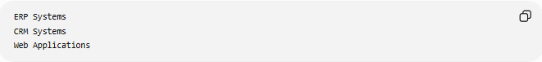
ERP Systems
CRM Systems
Web Applications

Databases
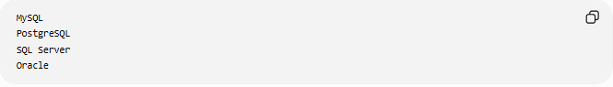
MySQL
PostgreSQL
SQL Server
Oracle

Files
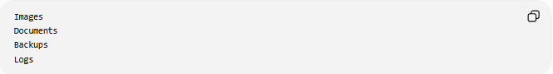
Images
Documents
Backups
Logs

Configurations
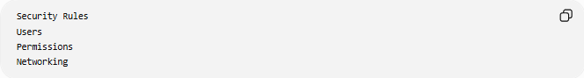
Security Rules
Users
Permissions
Networking

☁️ Cloud Migration Approaches
# Source: AI Source: Provided by: [Data Path: Persons Table -> ID Column: 1, Name_En Column: Motasem Essam] -> From: [ChatGPT] on [6/7/2026]
Rehost (Lift and Shift)
Move the server with minimal changes.
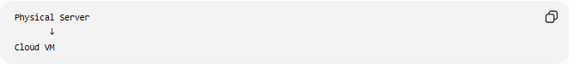
Physical Server
↓
Cloud VM
Fastest method.

Replatform
Make small improvements.
Example
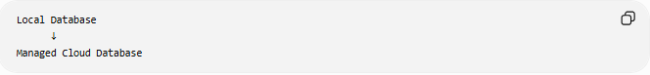
Local Database
↓
Managed Cloud Database

Refactor
Redesign the application for cloud-native architecture.
Example
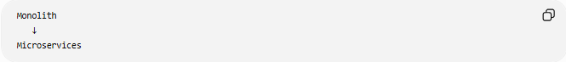
Monolith
↓
Microservices

🌍 Example Architecture
# Source: AI Source: Provided by: [Data Path: Persons Table -> ID Column: 1, Name_En Column: Motasem Essam] -> From: [ChatGPT] on [6/7/2026]
Before
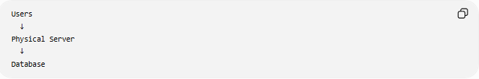
Users
↓
Physical Server
↓
Database

After
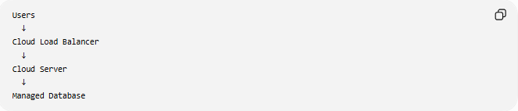
Users
↓
Cloud Load Balancer
↓
Cloud Server
↓
Managed Database

⚠️ Common Challenges
# Source: AI Source: Provided by: [Data Path: Persons Table -> ID Column: 1, Name_En Column: Motasem Essam] -> From: [ChatGPT] on [6/7/2026]
Data Transfer Size
Physical servers may contain:
Terabytes of Data
requiring significant migration time.

Downtime
Applications may need maintenance windows.

Security
Sensitive data must be protected during migration.

Network Changes
Updates may be required for:
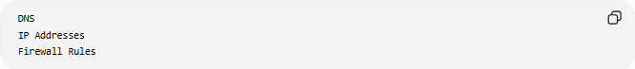
DNS
IP Addresses
Firewall Rules

Compatibility Issues
Some applications depend on:
Local Hardware
Legacy Drivers

✅ Benefits
# Source: AI Source: Provided by: [Data Path: Persons Table -> ID Column: 1, Name_En Column: Motasem Essam] -> From: [ChatGPT] on [6/7/2026]
Reduced Hardware Costs
No Server Purchases

Scalability
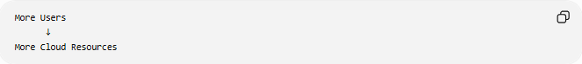
More Users
↓
More Cloud Resources

High Availability
Automatic Failover

Disaster Recovery
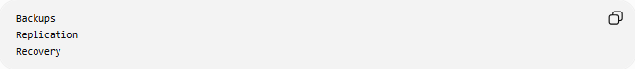
Backups
Replication
Recovery

Global Access
Users Worldwide

Simplified Maintenance
Cloud provider manages:
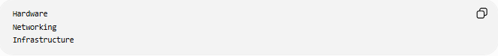
Hardware
Networking
Infrastructure

📊 Physical-to-Cloud vs Physical-to-Virtual
# Source: AI Source: Provided by: [Data Path: Persons Table -> ID Column: 1, Name_En Column: Motasem Essam] -> From: [ChatGPT] on [6/7/2026]
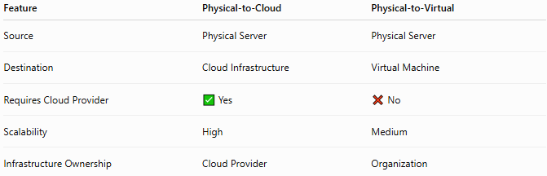
Feature | Physical-to-Cloud | Physical-to-Virtual
Source | Physical Server | Physical Server
Destination | Cloud Infrastructure | Virtual Machine
Requires Cloud Provider | ✅ Yes | ❌ No
Scalability | High | Medium
Infrastructure Ownership | Cloud Provider | Organization

Physical-to-Cloud
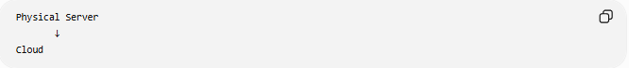
Physical Server
↓
Cloud

Physical-to-Virtual
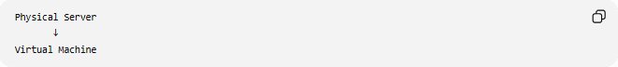
Physical Server
↓
Virtual Machine

🛠️ Common Migration Tools
# Source: AI Source: Provided by: [Data Path: Persons Table -> ID Column: 1, Name_En Column: Motasem Essam] -> From: [ChatGPT] on [6/7/2026]
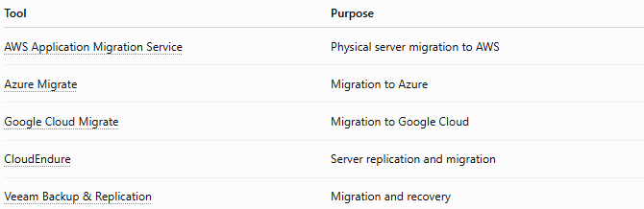
Tool | Purpose
AWS Application Migration Service | Physical server migration to AWS
Azure Migrate | Migration to Azure
Google Cloud Migrate | Migration to Google Cloud
CloudEndure | Server replication and migration
Veeam Backup & Replication | Migration and recovery

🧠 Simple Analogy
# Source: AI Source: Provided by: [Data Path: Persons Table -> ID Column: 1, Name_En Column: Motasem Essam] -> From: [ChatGPT] on [6/7/2026]
Imagine moving your business from a building you own to a fully managed office complex.
Before
Own Building
Maintain Everything

After
Managed Office Complex
Shared Services
You still run the same business, but the building maintenance is handled by someone else.
Physical-to-Cloud migration works similarly:
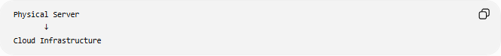
Physical Server
↓
Cloud Infrastructure
while preserving applications, operating systems, and data.

🧭 Summary
# Source: AI Source: Provided by: [Data Path: Persons Table -> ID Column: 1, Name_En Column: Motasem Essam] -> From: [ChatGPT] on [6/7/2026]
Physical-to-Cloud (P2C) Migration is a type of server migration where a physical server is moved directly into a cloud environment such as Amazon Web Services, Microsoft, or Google. It involves transferring the operating system, applications, databases, files, and configurations to cloud infrastructure. The main benefits are reduced hardware costs, scalability, high availability, disaster recovery, and simplified infrastructure management.

